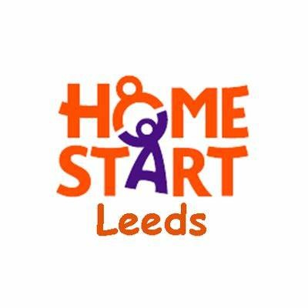
Monitoring Form

Home-Start Leeds is committed to promoting and achieving equality for our Staff Team, Volunteers, and the Families we support. It would be helpful if you could answer a few anonymous questions which will help us ensure that we are reaching out to all sections of our community.

Gender
Female |  | Male |  |  | I prefer to use my own term
I prefer to use my own term
If you prefer to use your own term, please provide this here:

Is your gender identity the same as the gender you were assigned at birth?
Yes |  | No |  | Prefer not to say

Sexual Orientation
Bisexual |  | Gay/lesbian |  |  | Heterosexual/straight
I prefer to use my own term
If you prefer to use your own term, please provide this here:

Do you consider yourself to have a disability?
Yes |  | No |  | Prefer not to say

Age
16 – 19 |  | 20 -24 |  | 25-29 |  | 30-34 |  | 35-39
40 - 44 |  | 45-49 |  | 50-54 |  | 55-59 |  | 60+

Ethnicity
Arab |  | Asian or Asian British: Other |  | Mixed: White and Black Caribbean |  | White: British
Asian or Asian British: Indian |  | Black or Black British: Other |  | Mixed: White and Asian |  | White: Irish
Asian or Asian British: Bangladeshi |  | Black or Black British: African |  | Mixed: White and Black African |  | White: Gypsy, Roma or Irish Traveller
Asian or Asian British: Chinese |  | Black or Black British: Caribbean |  | Mixed: Other |  | White: Eastern European
Asian: Other |  | Black: Other |  | Other |  | White: Other
Asian or Asian British: Pakistani |  | Other please state:

Religion and belief
Christian |  | Jewish |  |  | None |  | Buddhist
Hindu |  | Muslim |  |  | Sikh |  | Other
If you prefer to use your own term, please provide this here:

