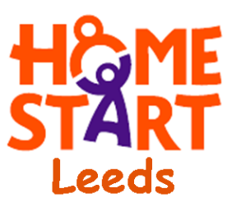

F17-F23, Hope House, 65, Mabgate, LS9 7DR
Tel: (0113) 244 2419
E-mail: office@home-startleeds.co.uk
www.home-startleeds.co.uk

March 2026

Dear Applicant,
Dads Community Worker (Part Time) 10 hrs per week

Thank you for your interest in the above post. On our website along with this letter you will find our application pack which includes:
- Application Form – with guidance for completion of your application
- Job Description & Person Specification
- Application Guidance Notes
- Equal Opportunities Monitoring Form.

Please complete the Application Form and Equal Opportunities Monitoring Form - applications must be returned by email and CV’s will not be accepted.

The closing date for applications is Tuesday 14th April 2026 at 9am.

No applications received after the closing date and time will be considered.

Interviews will be held on Thursday 30th April 2026.

Please note that we only provide feedback for candidates who have reached the interview stage.

If you have any questions, please contact myself at the above details.

Yours sincerely

Tracey Simpson-Laing
CEO

